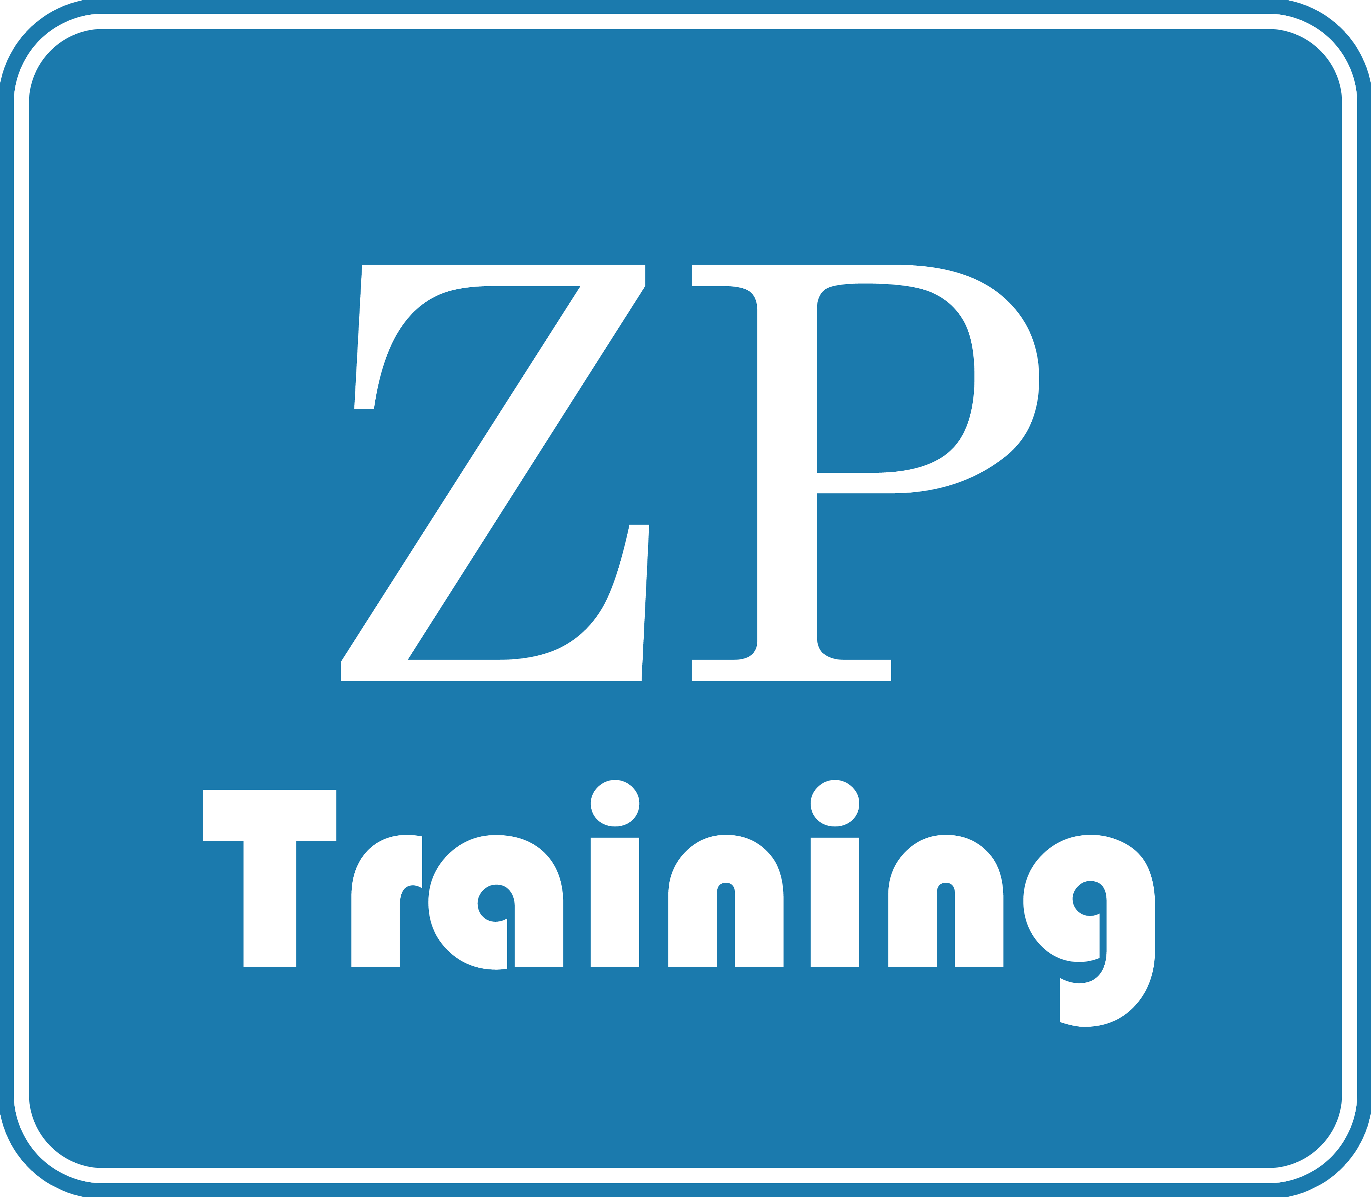
Zenith Professional Training

2022 Course Calendar
 | COURSE TITLE | DATES AND LOCATION
 | LEADERSHIP AND MANAGEMENT COURSES
1 | Operationalizing Corporate Ethics and Compliance (LM 5001) | 21^{st-} 25th March 2022 (Dubai)  16th -20th May 2022 (London)  14th – 18th November 2022 (London)
2 | Leadership Effectiveness and Team Excellence (LM 5002) | 9th -20th May 2022 (London)  15th -26th August 2022 (London)  7th -18th November 2022 (London)
3 | Managing Disruptive Change-Effective Strategies for Mitigating Post-Covid Effects  (LM 5003) | 14th -25th March 2022 (Dubai)  15th -26th August 2022 (London)  7th -18th November 2022 (London)
4 | Leadership, Motivation and Decision Making in Post-Covid Era (LM 5004) | 7th -18th March 2022 (Kigali)  18th -29th July 2022 (Dubai)  12th -23rd September 2022 (London)
5 | Emotional Intelligence and Relationship Management (LM 5005) | 14th -25th February 2022 (Dubai)  27th June-8th July 2022 (London)  10th -21st October 2022 (London)
6 | Stress Management-Delivering Results under Workplace pressure and stress (LM 5006) | 18th -22nd April 2022(London)  15th -19th August 2022 (London)  5th -9th December 2022 (London)
7 | Human Resources Management-Learning and Talent Development (LM 5007) | 14th -18th March 2022 (London)  15th -19th August 2022 (London)  5th -9th December 2022 (London)
8 | Organizational Agility-Embracing Change for Business Success after Pandemic – (LM 5008) | 4th – 15th April 2022 (Dubai)  11th -22nd July 2022 (London)  7th -18th November 2022 (London)
9 | Conflict Management and Negotiation Strategies (LM 8001) | 7th -18th February 2022 (London)  9th -20th May 2022 (London)  14th -25th November 2022 (London)
10 | Managing and Leading for Higher Productivity (LM 8002) | 7th -18th March 2022 (Dubai)  8th -19th August 2022 (Kigali)  14th – 25th November 2022 (London)
11 | Strategic Management and Leadership Skills for Managers (LM 8003) | 28th February – 11th March 2022 (London)  18th -22nd July 2022 (Dubai)  10th -21st October 2022 (Kigali)
12 | Training The Trainers- Executive Workshop  (LM 8004) | 14th -18th March 2022 (London)  15th -19th August 2022 (London)  5th -9th December 2022 (London)
13 | Developing and Managing Excellence in People and Projects (LM 8005) | 28th February – 11th March 2022 (Dubai)  8th -19th August 2022 (Kigali)  10th -21st October 2022 (London)
14 | Leadership Strategy and Crisis Management  (MP 8006) | 7th -18th March 2022 (London)  18th -29th July 2022 (Dubai)  12th -23rd September 2022 (London)
15 | Strategies for Leading Organizational Change and Development (LM 8007) | 18th – 29th April 2022 (Dubai)  18th -29th July 2022 (London)  5th -16th September 2022 (London)
16 | Corporate Ethics, Compliance and Integrity in Oil and Gas (LM 8008) | 14^{th-} 18th March 2022 (Dubai)  13th -17th June 2022 (London)  10th – 14th October 2022 (Kigali)
17 | Creating Strategic Business Process and Sustainability (LM 8009) | 7th -18th March, 2022 (London)  6th -17th June 2022 (Dubai)  12th -23rd September, 2022 (London)
18 | Leadership: Getting Results through Exceptional Capabilities (LM 8010) | 11th-22nd July 2022 (London)  15th -26th August 2022 (London)  7th -18th November 2022 (London)
19 | Managing Strategic Industrial Relations  (LM 8011) | 7th -18th February 2022 (London)  9th -20th May 2022 (London)  14th -25th November 2022 (London)
20 | Organizational Breakthrough Through Innovative Thinking (LM 8012) | 11th-22nd July 2022 (London)  15th -26th August 2022 (London)  7th -18th November 2022 (Dubai)
21 | Leadership: Inspiring Extraordinary Performance (LM 8013) | 18th -29 April 2022 (Dubai)  8th -19th August 2022 (London)  10th -21st October 2022 (London)
 | SENIOR EXECUTIVE LEADERSHIP COURSES
22 | Harnessing the Power of Dynamic and Competitive Strategies for Business Success  (EL 8001) | 7th -11th March 2022 (Kigali),  25th -29th July 2022 (Dubai)  12th -16th September 2022 (London)
23 | Creating, Leading and Sustaining a Culture of Innovation (ELP 8002) | 16th -20th May 2022 (Dubai)  11th -15th July 2022 (London)  10th -14th October, 2022 (London)
24 | Implementing Dynamic Capabilities for Sustainable Business Growth (ELP 8003) | 11th-15th July 2022 (London)  15th -19th August 2022 (London)  7th -11th November 2022 (London)
25 | Transformational Leadership in Dynamic Work Environments (ELP 8004) | 14th -18th March 2022 (London)  25th -29th July 2022 (Kigali)  19th -23rd September 2022 (London)
26 | Leading and Managing 21st Century Oil and Gas Business Venture (ELP 8005) | 7th -11th March 2022 (Kigali)  8th -12th August 2022 (London)  14th – 18th November 2022 (London)
27 | Top Executive Leadership Workshop (ELP 8006) | 7th -18th March 2022 (Accra)  13th -24th June 2022 (Dubai)  12th -23rd September 2022 (London)
 | PUBLIC RELATIONS COURSES
28 | Effective Diplomatic Skills for Protocol Officers (PR 5001) | 25th -29th April 2022 (Dubai)  22nd -26th August 2022 (London)  17th -21st October 2022 (London)
29 | Collaborative Partnership in the Delivery of Community Projects (PR 5002) | 11th -15th April 2022 (Kigali)  25th -29th July 2022 (London)  5th -9th December 2022 (Dubai)
30 | Managing Strategic Community Development and Relationships (PR 5003) | 11th -22nd April 2022 (Dubai)  25th July – 5th August 2022 (Kigali)  5th -16th December 2022 (London)
31 | Managing Public Relations for Strategic Edge (PR 5004) | 14th -25th March 2022 (Dubai)  15th -26th August 2022 (London)  7th -18th November 2022 (London)
32 | Delivering Competencies in Public Speaking and Presentations (PR 8001) | 18th -22rd April 2022 (London)  20th -24th June 2022 (London)  5th – 9th December 2022 (London)
33 | Corporate Communication: Adapting to Change (PR 8002) | 14th -25th March 2022 (Dubai)  4th -15th July 2022 (London)  14th -25th November 2022 (Accra)
34 | Advanced Skills for Secretaries and Personal Assistants (PR 8003) | 25th 29th April 2022 (Dubai)  22nd -26th August 2022 (London)  17th -21st October, 2022 (London
35 | Corporate Branding: Effective Tool for Business Success (PR 8004) | 21st -25th February 2022 (London)  25th -29th April 2022 (Dubai)  17th -21st October 2022 (London)
36 | Strategic Management-Corporate Social Responsibility and Deliverables  (PR 8005) | 7th -18th March 2022 (Kigali)  8th – 19th August 2022 (London)  21st November- 2nd December 2022 (Houston)
37 | Harnessing the Power of New Media to Drive Business Result (PR 8006) | 14th -25th March 2022 (London)  4th -15th July 2022 (London)  14th -25th November 2022 (Accra)
38 | Corporate Social Responsibility and Stakeholders Management (PR 8007) | 28th February – 11th March 2022 (London)  8th – 19th August 2022 (London)  21st November - 2nd December 2022 (Houston)
39 | Implementing Nigeria’s PIA (2020) Stakeholders Engagement and Management in the Oil and Gas (PR 8008) | 7th -18th March 2022 (Dubai)  8th-19th August 2022 (London)  21st November - 2nd December 2022 (Houston)
 | PUBLIC SECTOR, PROCUREMENT AND SHIPPING COURSES
40 | Digital Supply Chain Optimisation and Management (PSPS 5001) | 21st - 25th March 2022 (London)  25th -29th July 2022 (Dubai)  28th November - 2nd December 2022 (Kigali)
41 | Materials Procurement, Management and Control (PSPS 5002) | 21st March -1st April 2022 (London)  11th -22nd July 2022 (Dubai)  21st November-2nd December 2022 (Houston)
42 | Law Making and Legislative Drafting  (PSPS 5003) | 21st -25th March 2022 (Dubai)  12th – 16th September 2022 (Kigali)  21st -25th November 2022 (London)
43 | Managing Shipping and International Maritime Trade (PSPS 5004) | 7th -11th February 2022 (London)  4th -8th July 2022 (Dubai)  10th -14th October 2022 (London)
44 | The Legal Principles in Shipping (PSPS 5005) | 21st -25th March 2022 (Accra)  13th -17th June 2022 (London)  10th – 14th October, 2022 (London)
45 | Corporate Governance and Anti-Corruption Reforms (PSPS 8001) | 21st -25th March 2022 (Kigali)  12th – 16th September 2022 (London)  21st -25th November 2022 (Dubai)
46 | The Stakeholders-Impacts and roles in Shipping Management (PSPS 8002) | 7th -11th February 2022 (London)  4th -8th July 2022 (Kigali)  10th -14th October 2022 (Accra)
47 | E-Procurements-Effective Process Integration and Supply Operations (PSPS 8003) | 21st -25th March 2022 (London)  4th -8th July 2022 (Dubai)  21st -25th November 2022 (Houston)
48 | Project and Contract  Management-A modern Approach (PSPS 8004) | 7th -18th March 2022 (Dubai)  8th -19th August 2022 (London)  21st November– 2nd December 2022 (Houston)
49 | Anatomy of Shipping and Supply management (PSPS 8005) | 21st -25th March 2022 (Accra)  13th -17th June 2022 (London)  10th – 14th October 2022 (London)
50 | Warehouse Management, Strategy and Control (PSPS 8006) | 21st -25th March 2022 (Dubai)  13th -17th June 2022 (London)  10th – 14th October 2022 (London)
51 | Cargo Measurement and Tank Calibration (PSPS 8007) | 16th – 20th May 2022 (Dubai)  11th -15th July 2022 (Kigali)  5th -9th September 2022 (Kigali)
 | FINANCE AND ACCOUNTING COURSES
52 | Fundamentals of Financial Accounting (FA 5001) | 16th -20th May 2022 (London)  1st -5th August 2022 (Kigali)  7th -11th November 2022 (London)
53 | Accounting for Non-Accounting Executives  (FA 5002) | 14th -18th February 2022 (London)  18th -22nd April 2022 (London)  6th -10th June 2022 (London)
54 | Infrastructure Project Finance (FA 5003) | 7th -11th March 2022 (Dubai)  12th -16th September 2022 (London)  5th -9th December 2022 (London)
55 | Public Sector Financial Management (FA 5004) | 16th -20th May 2022 (Dubai)  1st – 5th August 2022 (London)  21st -25th November 2022 (London)
56 | Budgeting, Budgetary Planning and Control  (FA 5005) | 21st -25th March 2022 (London)  4th -8th July 2022 (London)  17th -21st October 2022 (London)
57 | Managing Internal Control (FA 5006) | 14th -18th March 2022 (London)  18th -22nd July 2022 (London)  10th -14th October 2022 (London)
58 | Project Finance PFI/PPP/Modelling  and Analysis (FA 5007) | 21st -25th March 2022 (Kigali)  4th -8th July 2022 (London)  17th -21st October 2022 (London)
59 | Cash Flow Analysis and Project Appraisal  (FA 8001) | 14th -18th March 2022 (London)  18th -22nd July 2022 (London)  10th -14th October 2022 (London)
60 | Strategies for Fraud Prevention and Detection in the Public Sector (FA 8002) | 16th -20th May 2022 (Dubai)  1st – 5th August 2022 (London)  21st -25th November 2022 (London)
61 | Combating Financial Crime Risk in the Financial Sector (FA 8003) | 16th -20th May 2022 (Dubai)  1st – 5th August 2022 (London)  21st -25th November 2022 (London)
62 | Corporate Management Accounting and Decision-Making Analysis (FA 8004) | 23rd -27th May 2022 (London)  8th -12th August 2022 (London)  14th -18th November 2022 (London)
 | OIL AND GAS MANAGEMENT COURSES
63 | Economics of Value Chain Optimization for Oil and Gas (OGM 5001) | 21st March-1st April 2022 (Kigali)  18th - 29th July 2022 (Dubai)  21st November-2nd December 2022 (London)
64 | Workshop-Sustainable Global Partnership and Technology (OGM 5002) | 14th -18th March 2022 (London)  25th - 29th July 2022 (Dubai)  21st -25th November 2022 (Houston)
65 | Stores Management and Inventory Control in the Oil and Gas (OGM 5003) | 21st-25th March 2022 (Dubai)  13th -17th June 2022 (London)  10th – 14th October 2022 (London)
66 | HSE Audit & Hazard Management in the Oil and Gas (OGM 5004) | 16th -20th May 2022 (London)  1st -5th August 2022 (London)  6th -10th November 2022 (London)
67 | Risk Based Process Safety Management  (OGM 5005) | 7th- 11th February 2022 (Dubai)  6th -10th June 2022 (London)  5th -9th December 2022 (London)
68 | Oil and Gas Materials Production Planning and Control (OGM 5006) | 14th -18th March 2022 (London)  12th – 16th September 2022 (Dubai)  12th -16^{t6h} December 2022 (London)
69 | Crude Oil Export: Terminal Operations  (OGM 5007) | 14th -18th February 2022 (London)  19th – 23rd September 2022 (Dubai)  5th -9th December 2022 (London)
70 | Crude Oil Marketing: Legal and Operations Perspective (OGM 5008) | 14th -18th February 2022 (London)  19th – 23rd September 2022 (Dubai)  5th -9th December 2022 (London)
71 | Global Reporting Initiative Standards and Sustainable Development Goals (OGM 8001) | 16th -20th May 2002 (Kigali)  22rd -26th August 2022 (Dubai)  21st -25th November 2022 (London)
72 | International Oil and Gas Contract Management (OGM 8002) | 7th -18th March 2002 (Dubai)  8th -19th August 2002 (London)  21st November– 2nd December 2022 (Houston)
73 | Oil and Gas Business-Legal and Taxation Perspective (OGM 8003) | 14th – 25th February 2022 (Dubai)  13th -24th June 2022 (London)  21st November-2nd December 2022 (Houston)
74 | Complex Negotiation Skills in the Oil and Gas  (OGM 8004) | 21st -25th February 2022 (London)  16th -20th May 2022 (Kigali)  14th -18th November 2022 (London)
75 | Oil and Gas Project Management  (OGM 8005) | 7th -18th March 2022 (Dubai)  8th -19th August 2022 (London)  21st November– 2nd December 2022 (Kigali)
76 | Supply Chain Operations and Management in the Oil and Gas-The Post-Covid Experience (OGM 8006) | 21st - 25th March 2022 (London),  25th - 29th July 2022 (Dubai) and 28th November - 2nd December 2022 (Houston)
77 | Corrosion Management in Production and Processing Operations  (OGM 8007) | 18th - 22nd April 2022 (London)  1st - 5th August 2022 (Dubai)  5th -9th December 2022 (London)
78 | Nigeria Oil and Gas Business-Complying with PIA 2020 (OGM 8008) | 14th -25th March 2022 (London)  11th -22nd July 2022 (Dubai)  21st November-2nd December 2022 (Houston)
79 | Maintenance Planning, Scheduling and Control in Oil and Gas (OGM 8009) | 21st- 25th February 2022 (Dubai)  13th -17th June 2022 (London)  5th -9th December 2022 (London)
 | OIL AND GAS FINANCE COURSES
80 | Risk-Based Auditing (Upstream and Downstream Operations) (OGF 5001) | 6th -10th June 2022 (London)  1st -5th August 2022 (London)  7th -11th November 2022 (London)
81 | Oil and Gas Project Funding (JV and PSC)  (OGF 5002) | 6th -10th June 2022 (London)  1st -5th August 2022 (Dubai)  7th -11th November 2022 (Kigali)
82 | Financial Reporting of Oil & Gas (JV and PSC)  (OGF 8001) | 16th -27th May 2022 (London)  5th -16th September 2022 (Dubai)  7th -18th November 2022 (Kigali)
83 | Oil and Gas Petroleum Economics (OGF 8002) | 14th – 25th February 2022 (Dubai)  13rd -24th June 2022 (London)  21st November-2nd December 2022 (Houston)
84 | Oil and Gas Integrated Joint Venture (IJV) Funding Workshop (OGF 8003) | 6th -10th June 2022 (London)  1st -5th August 2022 (Dubai)  7th -11th November 2022 (Kigali)
85 | Joint Venture Accounting (OGF 8004) | 16th -27th May 2022 (London)  1st -12th August 2022 (Dubai)  7th -18th November 2022 (London)
 | OIL AND GAS TECHNICAL COURSES
86 | Oil and Gas Technical Report writing  (OGT 5001) | 18th -22nd April 2022 (London)  20th -24th June 2022 (London)  5th – 9th December 2022 (London)
87 | Fundamentals of Unitization in Oil and Gas Production (OGT 5002) | 7th -11th March 2022 (London)  11th -15th July 2022 (London)  3rd -7th October 2022 (Dubai)
88 | Essentials of Petroleum Technology  (OGT 5003) | 14th – 25th February 2022 (Dubai)  13th -24th June 2022 (London)  21st November-2nd December 2022 (Houston)
89 | Process Safety Engineering and Maintenance in the Oil and Gas (OGT 5004) | 7th -18th March 2022 (Kigali)  8th -19th August 2022 (London)  21st November– 2nd December 2022 (Dubai)
90 | Petroleum Production Technology (OGT 5005) | 14th -18th March 2022 (London)  4th -8th July 2022 (Dubai)  21st -25th November 2022 (Houston)
91 | Geophysical Reservoir Characterization  (OGT 5006) | 21st – 25th February 2022 (Dubai)  20th -24th June 2022 (London)  21st -25th November 2022 (Houston)
92 | Tank Farm Operations-Performance and Sustainability (OGT 8001) | 16th – 20th May 2022 (Kigali)  11th -15th July 2022 (London)  5th -9th September 2022 (Dubai)
93 | Rock Physics and Seismic Reservoir Characterization (OGT 8002) | 7th – 11th March 2022 (Dubai)  1st -5th August 2022 (Kigali)  5th -9th December 2022 (London)
94 | Oil and Gas Reservoir Management  (OGT 8003) | 7th – 18th March 2022 (London)  1st -12th August 2022 (Kigali)  5th -16th December 2022 (London)
95 | Pore Pressure Analysis, Modelling and Prediction in Oil and Gas- OGT 8004 | 6th – 10th June 2022 (London)  5th -9th September (Dubai)  21st -25th November 2022 (Houston)
96 | Unitization in Oil and Gas Industry: Issues and Challenges (OGT 8005) | 7th -18th March 2022 (London)  11th -22nd July 2022 (London)  3rd -14th October 2022 (Dubai)
97 | Geomechanical Analysis-Mitigating against Compaction Related Casing Damage  (OGT 8006) | 6th – 10th June 2022 (London)  5th -9th September 2022 (Dubai)  14th -18th November 2022 (Houston)
98 | Clustered Oil and Gas Fields-Directional and Multilateral Drilling (OGT 8007) | 14th – 25th March 2022 (Dubai)  15th -26th August 2022 (London)  10th -21st October 2022 (London)
99 | Petroleum Refinery Dynamics-Process Yields Optimization- (OGT 8008) | 6th – 10th June 2022 (London)  5th -9th September 2022 (Dubai)  21st -25th November 2022 (Houston)
 | TRAVEL AND TOURISM COURSES
100 | Managing Travel and Tourism Operations  (TT 5001) | 14th -18th March 2022 (London)  12th – 16th September 2022 (Dubai)  3rd -7th October 2022 (London)
101 | Managing Travel and Tourism Development  (TT 5002) | 14th -18th March 2022 (London)  12th – 16th September 2022 (Dubai)  3rd -7th October 2022 (London)
 | INFORMATION AND TECHNOLOGY COURSES
102 | Information Technology Security & Management (Systems and Network Security Management (IT 5001) | 20th -24th June 2022 (London)  22nd -26th August 2022 (Accra)  17th -21st October 2022 (London)
103 | Machine Learning Revolution-Artificial Intelligence for Business Growth (IT 5002) | 20th -24th June 2022 (London)  22nd -26th August 2022(Accra)  17th -21st October 2022 (London)
104 | Computer Forensics and Incident Response  Technique (IT 5003) | 16th -20th May 2022 (London)  15th -19th August 2022 (London)  14th -18th November 2022 (London)
 | SECURITY AND SAFETY COURSES
105 | Conflict Management and Weapon  Awareness (SS 5001) | 14th -18th February 2022 (London)  16th -20th May 2022 (London)  14th -18th November 2022 (London)
106 | Prison Management and Reform: A Strategic Approach (SS 5002) | 6th -10th June 2022 (Dubai)  8th -12th August 2022 (London)  7th -11th November 2022 (London)
 | EDUCATION COURSES
107 | Supporting Teaching and Learning in Schools  (EC 5001) | 16th – 20th May 2022 (London)  11th -15th July 2022 (London)  5th -9th September 2022 (London)
108 | Assessing Learners using a range of methods  (EC 5002) | 16th – 20th May 2022 (London)  11th -15th July 2022 (London)  5th -9th September 2022 (London)

